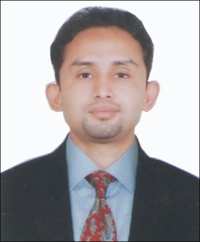
CURRICULLUM VITAE

JISMON JOSE

Mobile No: 056-7533184
Email: jisu487@gmail.com
_____________________________________________________________________________
Objective:
To improve my knowledge and skills through hard work, dedication and sincerity towards my job and to execute the responsibilities entrusted to me by the organisation to the fullest of my abilities and derive job satisfaction.

Academic Profile:

Subject | Year | University/School | Percentage
Pursuing MBA in Travel And Tourism | 2013 | MG University | pursuing
IATA in Airside And Safety | 2009 | Airline Training Academy | 92%
B.A-Philosophy | 2005-2008 | Calicut University | 64%
Plus Two Humanities | 2003-2005 | St.Paul’s H.S.S Irinjalakuda | 70%
SSLC | 2002 | St.Mary’s H.S Vynthala | 68%

Work Experience/ Post Held:

- Successfully completed 01 month on job training in Calicut International Airport , Kerala
- Successfully completed 02 months training as a Customer service agent- in AISATS, at Bangalore International Airport, Bangalore.
- Successfully worked as a Senior Customer Service agent in Air India SATS from 6th December 2010 to31st October 2013 at IGI Airport Terminal 3, New Delhi.
Duty Responsibilities:
- Handling all Airports functions (Check in, BMA, Boarding, Arrivals, ticketing and reservation) including flight handling& co-ordinate and manage a variety of services.
- Cargo Handling
- Co-coordinating with BMA,BBA,RAMP
- Preparing of FUEL DOCKET, FINAL MEAL ORDER, and all preflight works.
- Generating new ideas and concepts for the organization as well as employees.
- Ensuring continuous efforts for improvement of service and quality, safety aspects.
- Fulfill all the administrative and management requirements of the company.
- Ensure smooth functioning of the all Airport Operations
- Ensure efficient utilization of skills and resources to meet fine class of performance.
Professional Skills:
- Good leadership qualities combined with good communication and
management skills

- Good communication and interpersonal skills having flair for team building activity.
- Ability to handle all responsibilities with systematic and calculated approach
.
- Dedicated to work under pressure with long and flexible hours and willing to travel.
Computer literacy:
- MS Word
- MS Excel
- MS PowerPoint
My Certificcates:
B.A, IATA, DGR, AVIATION SECURITY
Personal Details:
Name :Jismon Jose
Gender : Male
Nationality : Indian
Date of Birth : 19-04-1987
Languages known : English, Malayalam, Tamil, Hindi
PermanantAddress : Poovathukan (H)
West Chalakudy (P.O.)
Thrissur (Dist.) Kerala, India
Local address : C/O Mr. Manoj kurian,
Dubai, and UAE.
Mobile: 056 7704964
Passport details
Passport No: H4806941
Date of Issue: 07-08-2009
Date of Expiry: 06/08/2019
Place of Issue: Cochin, Kerala, India
Visa Status: visit visa, expires on 25/03/14.
Reference:
- Mrsachin –Air India Superintendent mob-+91 9811181305
- MR B S Shekawat -Air India Superintendent mob +919999883678
Declaration:
I hereby declare that the above written particulars are true to the best of my knowledge and belief.
Place: Dubai Yours Sincerely
Date: Jismon Jose

