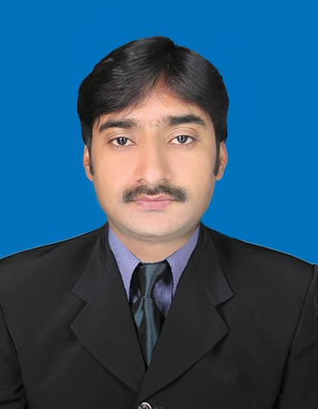
MUHAMMAD USMAN SALFI

[Al Quoz Near New Grand City Mall, Dubai] | [0057198217, 00923317027143] [usmansalfi143@gmail.com]
========================
Job Type:
Customer Services
Target Location:
United Arab Emirates
CUSTOMER SERVICE
■ Objective – Obtain a position as customer service representative, where my customer relations experience can be fully utilized to improve customer satisfaction and promote the company’s brand name.

Key Skills and Qualifications
Problem Analysis | Problem Solving | Organizational Skills
Customer Service Orientation | Adaptability | Initiative
Strong Interpersonal-Communication skills
- Knowledge about customer service applications and administrative procedures.
- Languages – Fluent in English, Spanish and Portuguese
- Relevant customer service courses
- High school diploma

Work Experience/Background
Customer Service Representative [ufone Franchize] Jalalpur Pirwala 2013 – Present
- Responded promptly and answered/resolved customer inquiries and complaints.
- Investigated and resolved service issues and/or product problems.
- Managed customers’ database accounts, performed customer verification and processed applications, orders and requests.
- Worked with administration: forwarded requests and unresolved issues to the designated resource by communicating and coordinating with internal departments.
- Kept records of customer interactions and actions taken, including – transactions, comments, inquiries and complaints.
- Supplied customers with written responses and information and followed up on customer communications.
Customer Service Representative [Hi Tac Computers ] Multan, 2011– 2012
- Communicated directly with customers by phone, electronically or face to face.
- Provided customers with technical support using maintenance procedures created with company products.
- Wrote and kept accurate records of discussions and correspondence with customers.
- Managed and supervised a team of customer services representatives.
- Provided customer service team with feedback.
- Met with other team managers to discuss possible improvements in customer service and company’s products.
- Trained and coached team members to deliver a high standard of customer service.
- Learned about products and services and kept up to date with changes.
- Kept ahead of technology developments by attending professional courses.
ACHIEVEMENTS
- Developed the customer service policy for the organization: Developed customer service procedures, performance level and QA standards for the organization.
- Evaluated changing factors frequently to achieve high customer satisfaction level.
- Analyzed statistics and other data to determine the level of customer service performance achieved by the team.
PERSONAL INFORMATION

Father’s Name : Muhammad Usman Salfi
Date of Birth : 01 March 1985
Marital Status : Single
Religion : Muslim
Nationality : Pakistani
CNIC : 36301-7938601-9

VISA STATUS: Visit Visa
Expiry Date: 13 June 2014

QUALIFICATION:
M.Sc Economics
Major Subjects: Micro Economics, Macro Economics and Ecnomatrics.
Completion date: April 2014
Obtained Marks Percentage: 66%

Post Graduate Diploma in Business and Applied Mathematics in Computer.
Major Subjects: Ms- Office, Java, C++
Completion year: 2006 - 2007
Obtained Marks Percentage: 70%

B.Sc
Major Subjects: Statistics, Mathematics and Economics
Completion year: 2005
Obtained Marks Percentage: 54%

Intermediate, I.C.S
Major Subjects: Physics, Mathematics and Computer
Completion year:2003
Obtained Marks Percentage: 58%

Extra Skills:
Urdu, English and Arabic Typing
Using of Internet
Typing speed near about 40 words per minute.

Languages:
English Level: Fluent
Urdu Level: Native

Reference:
Reference will be furnished if desired.

