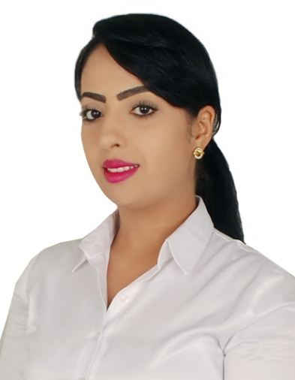
Curriculum Vitae
Of
HASNA MOUSTAQUIL

CAREER OBJECTIVE:
Looking for a company where I can apply my knowledge & maximize my skills and to be part of a team & be a part of the company’s growth & success.

CAREER HISTORY

From | To | Position | Company
MARCH 2012 | PRESENT | SENIOR SALES EXECUTIVE  FOR SHESIEDO | PARIS GALLERY  PARIS GALLERY -DUBAI MALL
Job Description:
- Handling Customer Service.
- Encourage and convince the customer about the product to achieve company and department target.
- Direct reporting and guided as per instruction of the manager.
- Supervise the stock availability.
- Control the arrival and the opening of the stock.
- Display and arranging product as per company’s concept and brands.
- Counting the shipment and immediate display to achieve sales target.
- Handling Inventories
- Resolve the customer problems and to let them satisfied with a good service.
- Report to direct manager the problems and conflicts that occure during the shift
- Providing suggestions that can boost the sales
From | To | Position | Company
FEBRUARY 2010 | JANUARY 2012 | SENIOR SALES EXECUTIVE  FRENCH DEPARTMENT STORES | ‘’GALLERIE LAFAYETTE ’’  DUBAI MALL-DUBAI
Job Description:
- Customer Service.
- Encourage and convinced the customer about the product to achieve companies and departmental target.
- Following the instruction of the manager.
- Organize and communicate between the manager and the staffs
- Monitoring the staffs
- Arranged weekly schedule
- Supervise the stock works.
- Control the arrival and the opening of the stock.
- Display and arranging product as per companies concept and brands.
- Counting the shipment and immediate display to achieved sales target.
- Handling Inventories
- Resolve the customer problems and to let them satisfied with a good service.
- Report to direct manager the problems and conflicts that occur during the shift
- Providing suggestion that can boost the sale.

From | To | Position | Company
DEC. 2005 | MAY 2007 | CASHIER  BERSHKA-QATAR | AZADEA HOLDING  QATAR
Job Description:
- Open and close the cash
- Organize the files
- Receiving and sending faxes
- Counting the money of the fund cash
- Control the petty cash
- Making the daily staff breaks
- Receiving the calls and communicate between the supervisor and the staffs
- Doing the transactions if it’s cash or credit
- Try to convince the customer about the product
- Call the customer and inform them about the new arrival in order to increase the sale
- Shipments confirmations
- Doing transfers between stores
- Banking the money
- Do the customer’s reservations
- Receiving all the files of the other shops of the company
- Train the new cashiers

From | To | Position | Company
JANUARY 2003 | JULY 2004 | RECEPTIONIST | HOTEL: “SHERATON “CASABLANCA: MOROCCO
Job Description:
- Book in and out of the new arrival guests
- receive the calls
- control the guest goods
- answer all the guests’ suggestions
- try to give the guests any information they need
- Follow up payments from clients.
- Answering phone calls courteously.
- Making some clients is extremely pleased with warm and performed.
From | To | Position | Company
march 2001 | October 2003 | Sales consultant | O”gallery  “CASABLANCA: MOROCCO
Job Description: dolce and gabbana,gf ferre,just cavalli,roberto cavalli.versace

- Book appointments with VIP clients to advise and to select to them there style and to give fashion advices
- Handle many luxury brands
- Receive the stock and contact my clients to get the best arrivals
- Display the new arrival according to the standard and the guide line of the brands
- Inform the manager about the best selling pieces and the slow movers to spot light on them
- Control the stock and to manage and to support for the inventory
- Send and receive e mails to and from my clients to be online all the time
- Try to give the best and the supreme satisfaction to my clients
- Apply the company’s rules
- open and close my section and send reports to my direct managers
- open and close the cash and to keep arranged
- check the reservations and follow up with the clients to release or to extend the reservation according the company rules

SKILLS and TRAINING ATTENDED:
- Informatics.
- power point
- Navigation on the Net.
- Selling technique certificate
- Customer service certificate 2008 Qatar
- Holding Valid UAE Driving License

PERSONAL INFORMATION:
Full Name : Hasna Moustaquil
Date of Birth : 12 December 1983
Place of Birth : Casablanca, Morocco
Marital Status : Single
Nationality : Moroccan
Address : Dubai International City, Russia V02 Cluster,
Dubai, U.A.E.
Mobile : +971-567058580
E-mail : hasna.moon@hotmail.fr
Languages : Fluent in Arabic, French, English
Visa Status : Residence – Transferable
References : Available upon request

