Ahmed Mohamed Saad
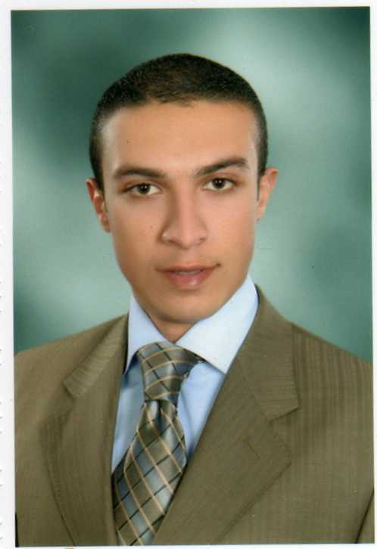
Personal Information:
- Name: Ahmed Mohamed Saad Abdel kader
- Date of birth: may 1,1987
- Place of birth: Alexandria, Egypt
- Current place: Dubai ,UAE
- Religion: Muslim
- Marital status : single
- Military status: done
- E-mail: Ahmad.m.saad@hotmail.com
- Phone number:+971561228442

Objective:
- To secure a good position in your organization & develop my interpersonal and technical skills.
Education:
- Law licentiate 2007(faculty of law - Alexandria university)
Language:
- Arabic: mother language
- English: excellent written and very good spoken
- French: little
Professional experience:
- Before graduation:
    - Sales field: Sales for computer Hardware Company.
    - Tourism field: Zak hotel, Hurghada.
- After graduation: 2 years experience with companies &banks cases.
    - Mohamed Saad legal consulting office (civil law).
    - Ahmed Abu shady company (debit collectors).
- UAE experience:
- CTS:RTA project
- Position: customer service representative

Computer skills:
- ICDL (international computer driving license)
- Excellent Command Of Windows OS Versions & Variable Applications (PROFESSIONAL)
- Word Processing (Word), Spread Sheet Programs (Excel) (Professional)
- Internet Field (Professional)

Driving license :
- Egyptian: available
- UAE: pending

Self-Skills:
- Outstanding Management Communication and Presentations Skills.
- Open Minded, Ambitious, Ready To Work Under Pressure.
- Active Dynamic, And a Hard Worker.
- Able To Learn In A Short Period.
- Helpful Among Team Work.
- Ability To Achieve Immediate And Long-Term Goals And Meet Operational Deadlines
- Have the ability to solve problems, tested with continuous problem solving exercises given as assessments, which may require mathematical analysis and evaluation.
Hobbies:
- Swimming, reading, listening to music, running, and travel

Available On Request
Thanks for Your Time

Best. Regards
AHMED SAAD

