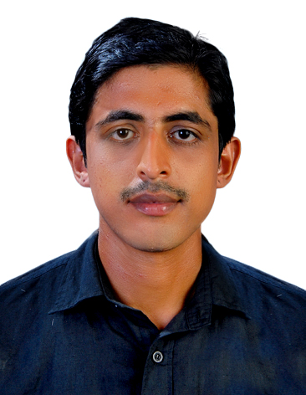
Name : RINOJ MV
Sharjah – United Arab Emirates
Contact No : 056-2781411
Email : rinojmv@gmail.com

PROFESSIONAL OBJECTIVES

Professional Objectives: Looking for a career in challenging professional world where growth prospects are unlimited & working in a challenging atmosphere so that my skills shall be utilized for continuous growth of advanced of the organization.

SYNOPSIS

Organization | Position | Period | Location
LE- MERIDIEN BANGALORE | INDUSTRIAL TRAINING | 6 MONTHS | INDIA
MOCHA BANGALORE | BREW MASTER | 1 YEAR | INDIA
CAFFECHILLM GOA | KICHEN INCHARGE | 14 MONTHS | INDIA

KEY SKILLS AND COMPETENCIES

1. Able to cook a variety of different dishes including English and foreign dishes.
2. An awareness of all health and hygiene requirements.
3. Experience of restaurant / pub / inn style food production.
4. A good track record of achieving and consistently maintaining target Gross
Profit percentages.
EDUCATIONAL QUALIFICATION

CRAFTMANSHIP COURSE IN FOOD PRODUCTION(IHMCT KOVALAM, KERALA)
PLUSTWO(PPHSS KANNUR, KERALA)
Catering skills:
- Extensive knowledge of food safety and health regulations.
- Providing guidance and direction to subordinates, including setting performance standards and monitoring performance.
- Experience of cooking in high volume outlets.
- Knowledge of kitchen refurbishment programmes.
- Knowledge of Chinese, Indian, and Fusion cooking.

OVERVIEW ABOUT MYSELF

o Confident of getting through with all my assignment on time.
o Able to handle all types of Customers and Situation Handling.
o Ability to work under pressure, positive attitude, enthusiasm and mental toughness
o Can easily cope up with changing situations
o Goal oriented

Languages Known:-

o English, Malayalam, Hindi ,Kannada and Tamil.

PERSONAL INFORMATIONS

Name | RINOJ MV | Father's Name | RAJAN MV
Nationality | Indian | Gender | Male
Religion | Hindu | Marital Status | Single
Date Of Birth | 20/01/1987 | Place of Birth | KANNUR
Passport No | G3769759 | Place of Issue | CALICUT
Visa Status | VISITING

I hereby certify that the above information is true and correct to the best of my knowledge and ability. I hope my Education and Experience will help me to get an opportunity to serve with your esteemed organization. If I get a chance to serve I will discharge my duties to my superior's entire satisfaction.

Place: SHARJAH (United Arab Emirates)

